Sprawozdanie nr2
Sieci Komputerowe 2024

Grupa: ISI5
Wykonał: Ruslan Zhukotynskyi

1. Wireshark - jest to taki program lub sprzęt komputerowy który służy do przechwytywania i zapisywania ruchu sieciowego.

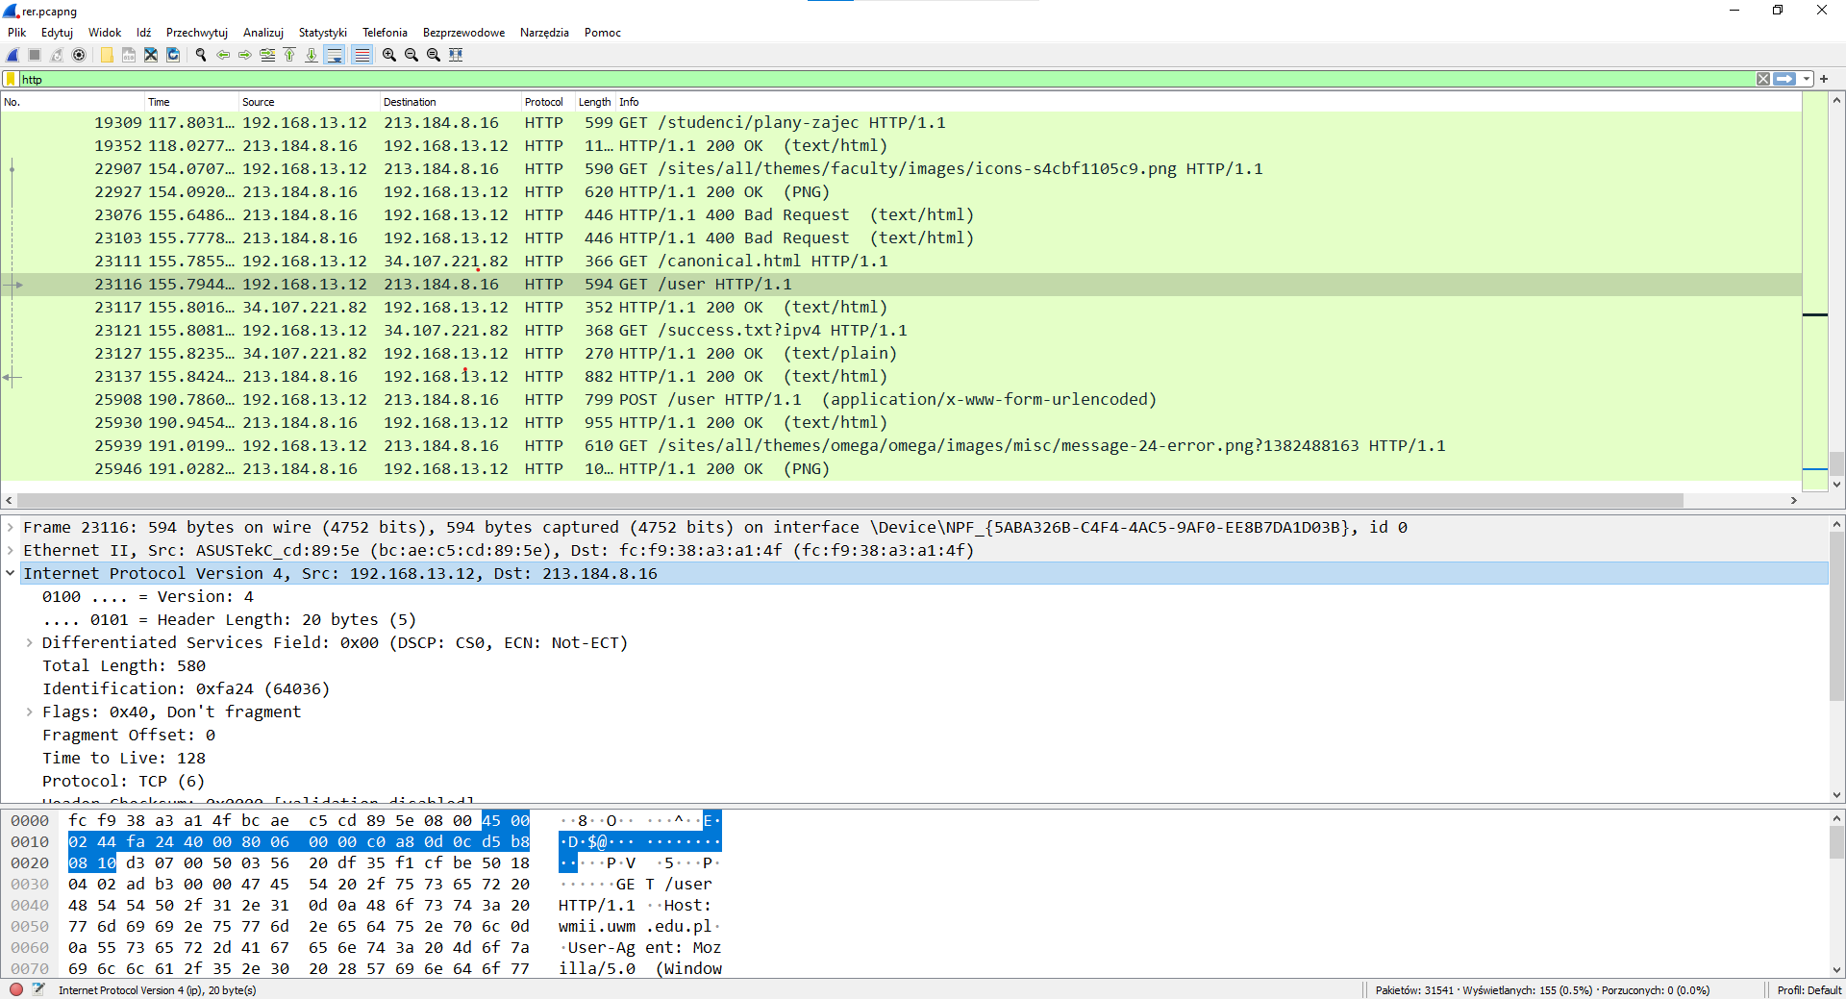
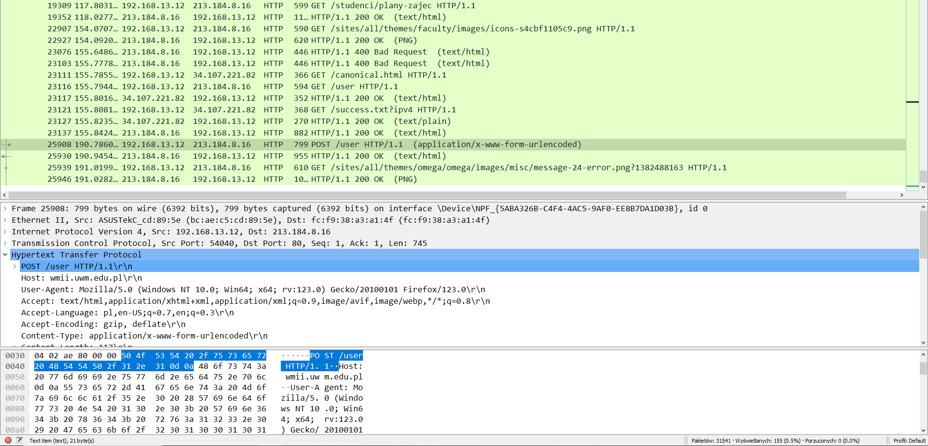
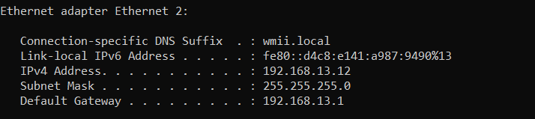
2.

Wewnętrzny adres IP : 192.168.13.12
Zewnętrzny adres IP : 213.184.8.154
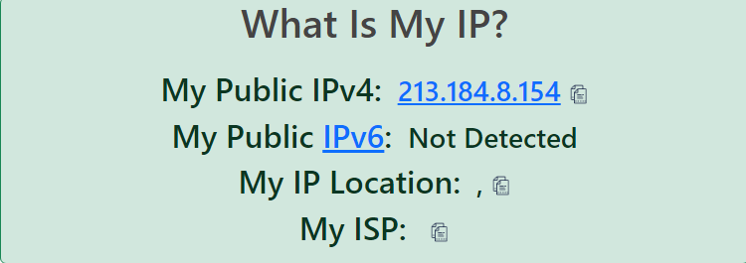

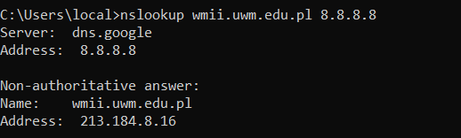

3. za pomocą strony internetowej speedtest.net mogę wymierzyć prędkość dostępu do Internetu.
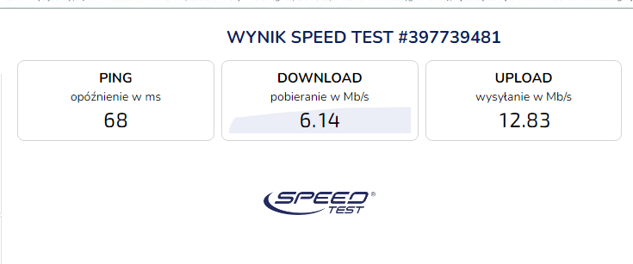

4.
5.
6.

7.

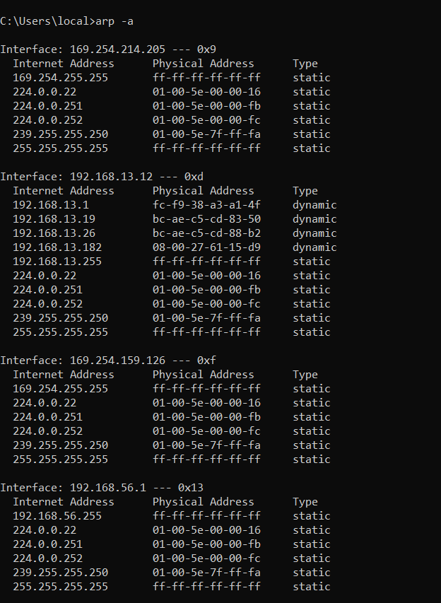

8. # Copyright (c) 1993-2009 Microsoft Corp.
#
# This is a sample HOSTS file used by Microsoft TCP/IP for Windows.
#
# This file contains the mappings of IP addresses to host names. Each
# entry should be kept on an individual line. The IP address should
# be placed in the first column followed by the corresponding host name.
# The IP address and the host name should be separated by at least one
# space.
#
# Additionally, comments (such as these) may be inserted on individual
# lines or following the machine name denoted by a '#' symbol.
#
# For example:
#
# 102.54.94.97 rhino.acme.com # source server
# 38.25.63.10 x.acme.com # x client host

# localhost name resolution is handled within DNS itself.
# 127.0.0.1 localhost
# ::1 localhost

127.0.0.1 view-localhost # view localhost server
213.184.8.32 AUTOCADSL2019
# Added by Docker Desktop
192.168.13.12 host.docker.internal
192.168.13.12 gateway.docker.internal
# To allow the same kube context to work on the host and the container:
127.0.0.1 kubernetes.docker.internal
# End of section

